**DFS Example:**

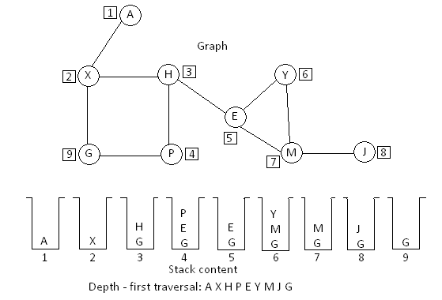

Consider the above graph, let node A be the starting vertex

1. Begin with node A push onto stack
2. While stack not equal to empty

Pop A; state A is visited

Push nodes adjacent to A to stack and make their state waiting

1. Pop X; state B is visited

Push nodes adjacent to X into stack

1. Pop H; state H is visited

Push nodes adjacent to H into stack already G is in waiting state, then push nodes E and P

1. Pop P; state P is visited

Push nodes adjacent to P are H, G, E; H is already in visited state, G and E are in waiting state

1. Pop E; state E is visited

Push adjacent nodes, H is already visited, so push Y and M into the stack

1. Pop Y; state Y is visited

Push nodes adjacent to Y into stack, E is visited, M already in waiting state

1. Pop M; state M is visited

Push nodes adjacent to M, which is J

1. Pop J; state J is visited

No nodes are there to be process

1. Pop G; state G is visited

Now the stack is empty

The depth – first order of the visited nodes are **A X H P E Y M J G**